Curriculum vitae:

Naam: Marlou de Kuiper
Geboortedatum: 24-03-1954
Karperstraat 36
3525CB, Utrecht
Marlou.dekuiper@gmail.com
Marlou.dekuiper@hu.nl
00(31)653228099

https://www.linkedin.com/profile/view?id

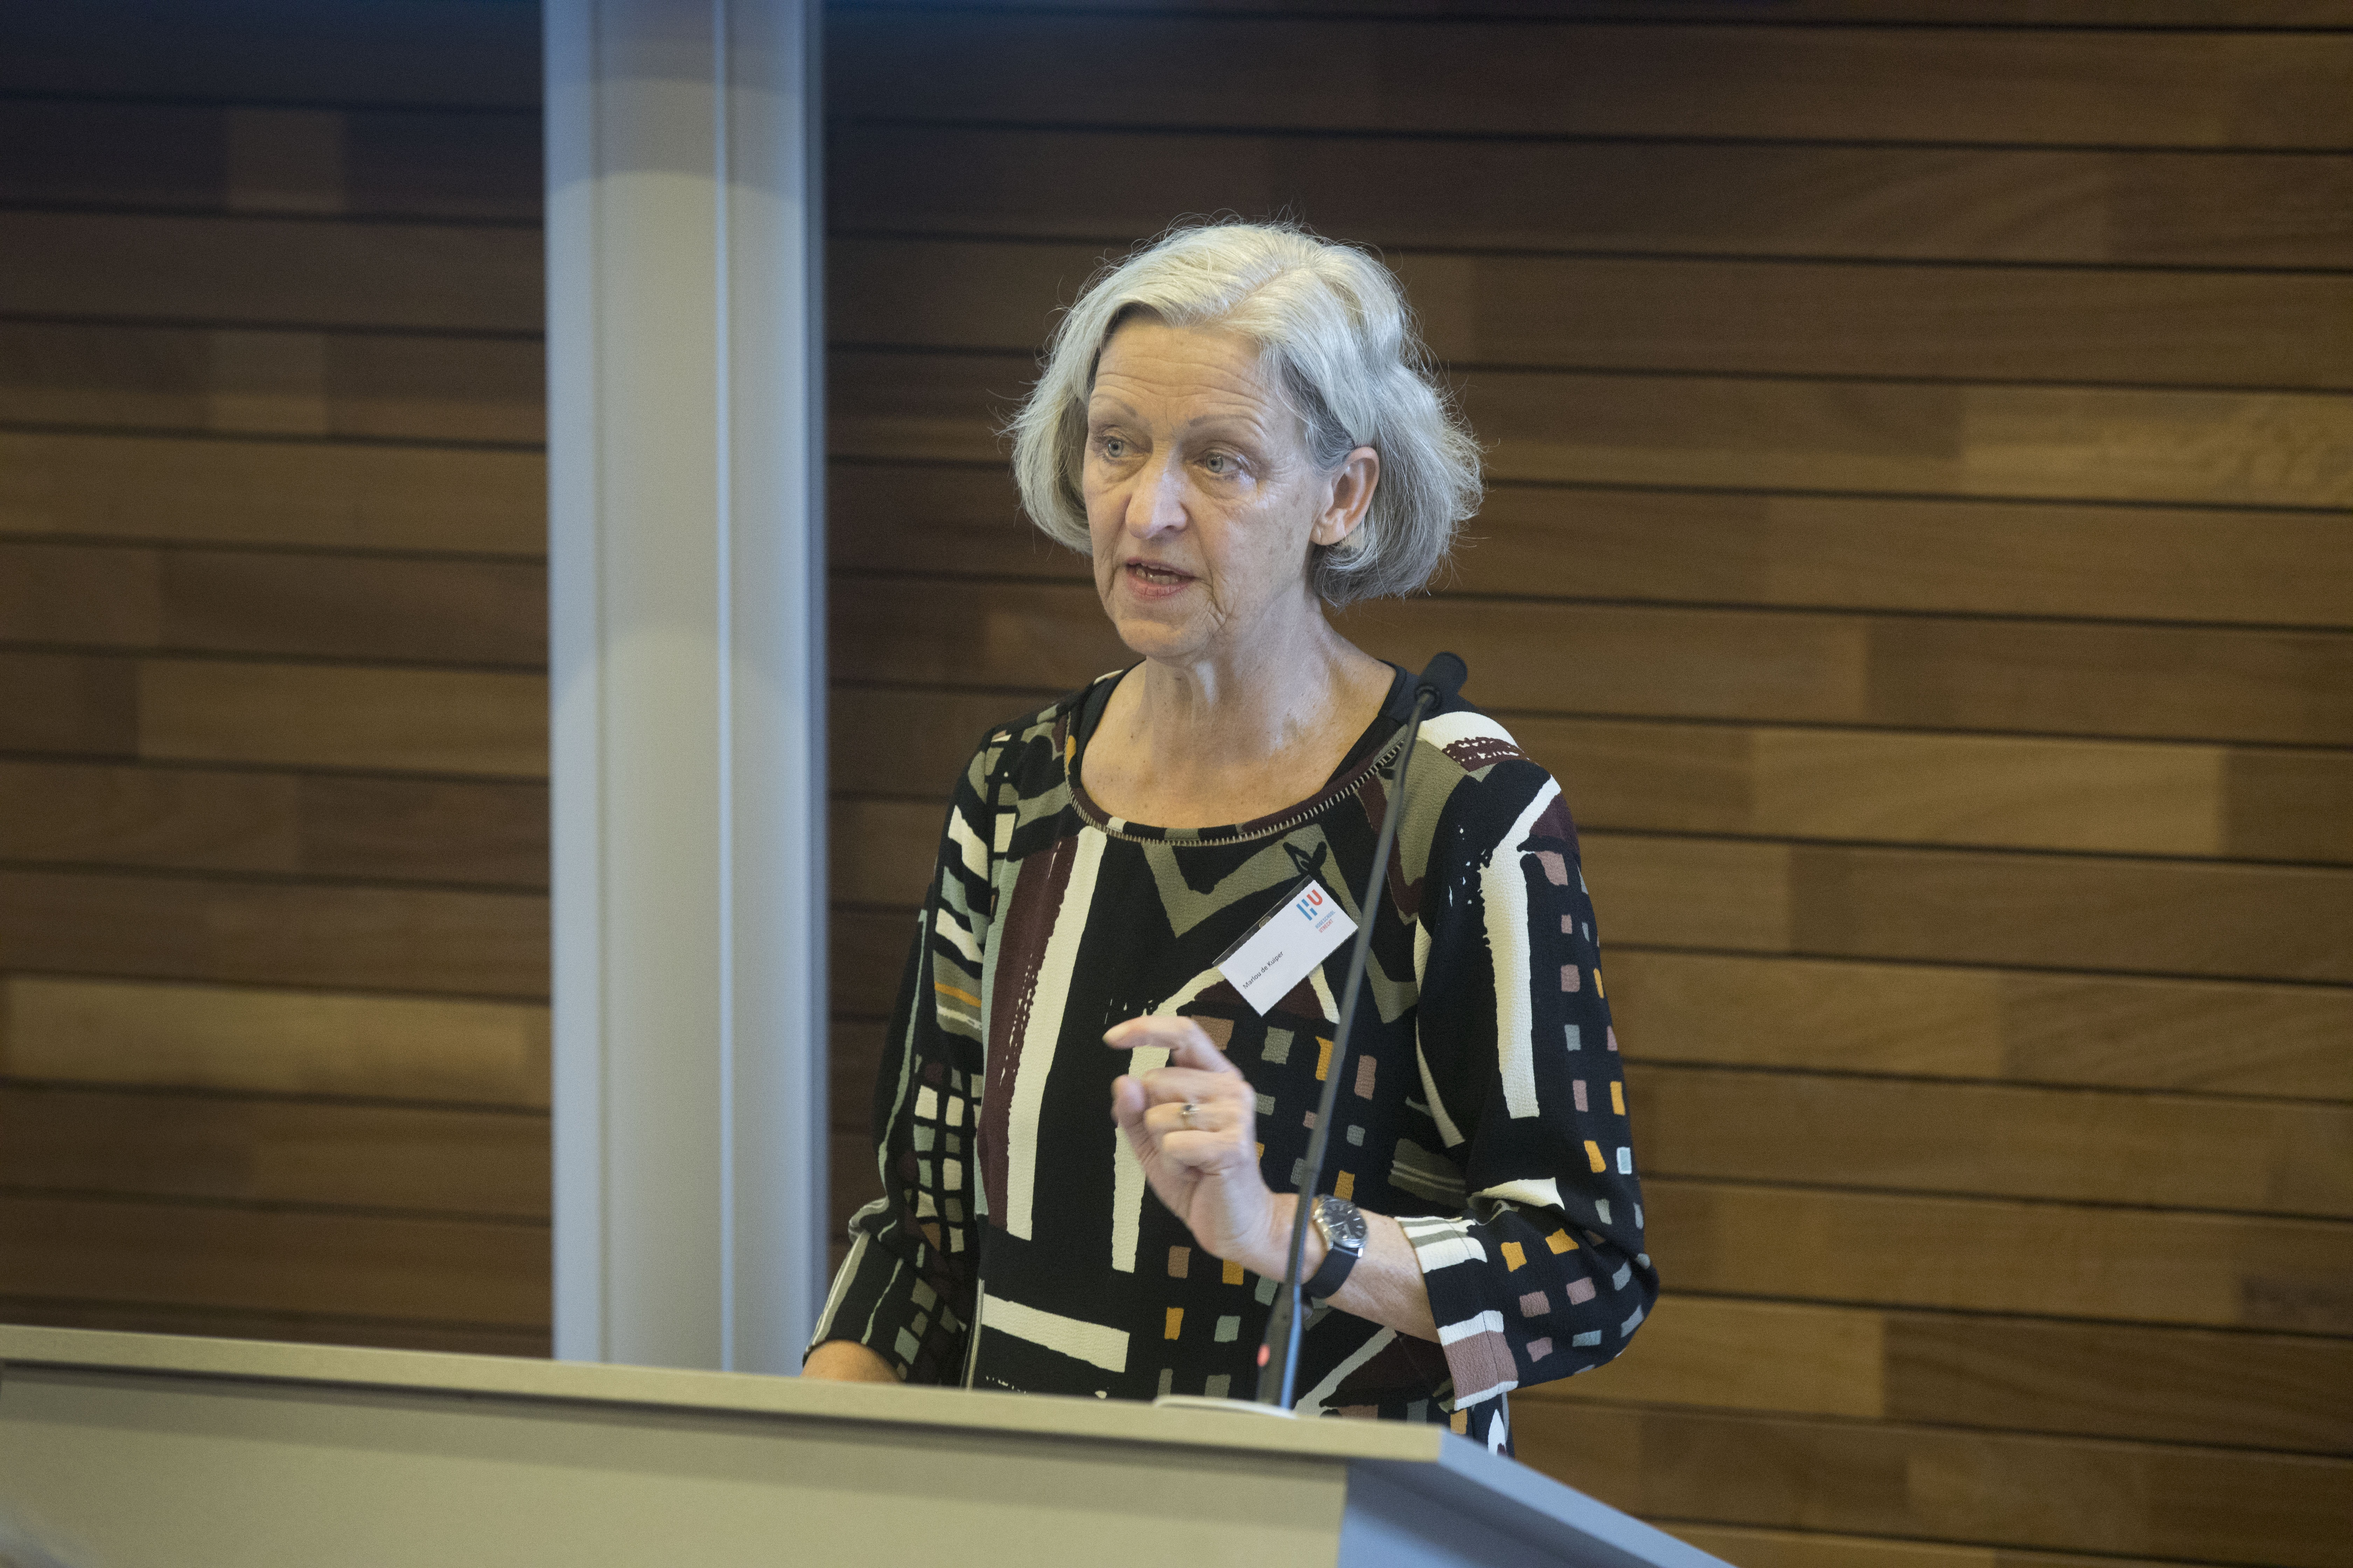

Main personal qualities:
Innovative, inspiring, resourceful, industrious, analytical.. I am good at dealing with chaos and creating order. I work well with other people and independently.

Education:
2012-present PhD research writing-to-learn
2010 ALIA course (Authentic Leadership in Action, Module The Art of Hosting Transformational Change/ Theory U)
2009 Registered Coach
Critical Thinking Train the Trainer Certificate
2008 Trainer International Classification of Functions /Certificate
Human Dynamics/ Certificate
2007 Educational Management Studiecentrum bedrijf en overheid
1998-2000 Registered Supervisor Hogeschool Windesheim, Zwolle
Reg. Nr. RS 10934A
1988-1991 Master in Science of Nursing Degree Hogeschool van Utrecht/
University of Wales/Cardiff
1987 Tropical Hygiene in Mother and
Child Health Great Ormond Street, London
1981-1982 Bachelor Degree in Education CICSA, Hogeschool Amsterdam
1978 Tropical Hygiene Havenziekenhuis, Rotterdam
1975-1976 Pediatric Nursing Ziekenhuis Ziekenzorg, Enschede
1971-1975 Nursing Education ‘t Venderink, Hengelo

Work:
Since 2015 Member of the team coaches team (part-time) and project leader of writing across the curriculum
Since 2007- Development and Management Master of Science Integrated Care Design
Development Leadership for Change course
Development internationalisation and distance learning.
Development Nursing Education in the Caribbean: Aruba, Bonaire, Curacao, Surinam, Barbados
Member innovation team, learning communities and knowledge management
Development post-graduate and Master Education

2003-2007 Productmanager of:
Master Advanced Nursing Practice
Master in Science of Nursing
Clinical Nurse Specialist Education
Innovation in Health Care Course
Applied Science Course

2002-2003 Member of the Position: Nursing and Paramedical Care for the Chronically Ill
Since 2001 Teaching clinical decision making, Mother and Child Health, Prevention, Trainer Personal Effectiveness.
Since 1995 Independent advisor on development of nursing care process management. Registered supervisor, trainer and coach.
1993 Faculty member Bachelor in Nursing Education.
Faculty member Innovations in Health Care Degree
!987-1998 Courseleader Pediatric and Neonatal Nursing Care Degree, Deltion College, Zwolle
1982-1986 Guiné-Bissau
1978-1981 Mother and Child Health ambulatory and Preventive Care, Ortum, Kenya
1977 Teamleader, Harbor Hospital, Rotterdam
1971-1976 Nursing Education and Pediatric Nursing Education, Ziekenhuis Ziekenzorg, Enschede

Lectures and workshops:
I have lectured and given workshops at more than 100 International and National Conferences,
a list of these can be provided.

Professional membership:
Since 2001 National Council for Supervisiors
Since 1999 Honour Society of Nursing, Sigma Theta Tau, International, Utrecht
Since 1997 Trustee for the Neuman Systems Model
Since 1992 Association for Nursing Science in the Netherlands
Since 1977 Association for Pediatric Nursing in the Netherlands

Board functions:
2007-2013 Member of the Board of Rho Chi Chapter of Sigma Theta Tau, Counselor and member of the European Bussiness Meeting
since 1995 Member of the Board of Trustees International Neuman Systems Model Association
1994-1995 Member of the board of Trustees of the Association for Pain in Children
1991-1995 Chairperson of the Alumni Association of the Master in Nursing Society
  - Chairperson of the regional Board for Breastfeeding
  - Chairperson of the Educational Committee for Pediatric Nursing, Holland

Other activities:

Member of the Quality Council consensus Group for pain in Children.
Research proposal for the Association of pediatric nursing: national educational standards.
Validation of protocols for emergency care.
curriculum development, Deltion College, Zwolle
curriculum development Institute of Higher Education, Zwolle
Development of courses and training in:
Transcultural Nursing,
Pain in Children
Systems Theory
Personal effectiveness
Leadership
Coping with Chronic Illness
Self-management
Chronic Care Model

Organisation of:
Yearly conference Systems theory
Yearly conference Advanced Nursing Alumni
Conferences on Spirituality, Rehabilitation, Transcultural Nursing, European Bussiness Meeting

Guest lectures at:
Institute of Higher Education, Leiden: Public Health Nursing
Institute of Higher Education, Deventer: Transcultural Nursing
Thuiszorg Salland: WHO certificate breastfeeding
Institute of Higher Education, Utrecht: Bachelor Physical Therapy, Transcultural care
Post-graduate degree Public Health: OKZ: Mother and Child Health
Institute of Higher Education Zwolle: visies op zorg
Institute of Higher Education: Opleiding Sociaal Psychiatrische Verpleegkunde

Publications:

Articles:
Merks, A; Verberk, F; De Kuiper, M; Lowry, L.(2012) Neuman Systems Model in Holland: An Update. Nursing Science Quarterly. 25 p 364-368

Kuiper, M. de (2005) Challenges for the future: knowledge models applied to nursing practice. (Uitdagingen voor de toekomst : kennismodellen toegepast in de verpleegkundige praktijk) Oncologica 22(1): 31-33

Duyvendak,W.; R. van Dommelen; M. de Kuiper (2005) Consequences of Advanced Nursing Practice Association Degree. TVZ tijdschrift voor verpleegkundigen 115(1): 21

Mourik, A.; M. de Kuiper (2004) Images and attitudes: Nursing and the Elderly. )Beeldvorming en attitude : verpleegkundigen en ouderen). TVZ tijdschrift voor verpleegkundigen 114(7-8 ): 34-37

Kuiper, M. de (2002) Boundaries for Pediatric Nursing: holistic nursing and negotiating. (Grenzen aan de kinderverpleegkunde : holistisch verplegen en onderhandelen). Tijdschrift kinderverpleegkunde 8( 4 ): 24-25
Kuiper, M. de; M. Arends (2001) Reflection is practical. (Reflecteren is praktisch). Tijdschrift Kinderverpleegkunde. 7(4): 6-8

Kuiper, M. de (2001) The Neuman Systems Model. (Het Neuman Systems Model). Tijdschrift Kinderverpleegkunde 7(4):22-23

Books and contributions to Books:

De Kuiper, M; de Jong, A; in: Beckman, S; Fawcwett, J; Neuman Systems Model. Celebrating academic-practice partnerships. Chapter 3: Teamwork and Collaboration.

Ettema, R.; de Kuiper, M.; Demand, supply chain management. In: Hammelbrug, R; Lubbers, W. J. ; Nauta, N.; (2014) Veranderde samenwerking in de zorg. Bohn, Stafleu en Van Loghum, Houten

Van Spil, J.A.; Van Muilekom, H.A.M.; Van de Walle-van de Geijn, B.F.H. (2013) Oncologie. Handboek voor verpleegkundigen en andere hulpverleners. Bohn, Stafleu & Van Loghum

Van de Kooij, M; De Kuiper, M. Een dagreis door Theorie U. In: Klomp, K. (2012) Bloei! Werken aan geluk in organisaties. Uitg Asoka, Rotterdam

De Kuiper, M; De Jong, A. (2012) Klinische besluitvorming voor verpleegkundigen (Clinical decision making for nurses). Bohn, Stafleu & Van Loghum, Houten.

Jansen, M; de Kuiper, M. (2011) The new health professional. Boxexpress, Utrecht

Kuiper, M. de. (2011) The Created Environment In: Neuman, B Fawcett J :The Neuman Systems Model, Fifth Edition. Prentice Hall, New York, hoofdstuk 5

Kuiper, M de (2009) Designing Care Trajectories (Ontwerp van zorgtrajecten/zorgketens). Bohn, Stafleu, Van Lochem

Jansen M; de Kuiper M (2007) Advanced Nursing Care (De expertverpleegkundige). Bohn, Stafleu, van Lochem

De Kuiper, M (2006) Clinical Specialist Nursing Care. (De verpleegkundig Specialist). Handboek Zorg Thuis. Reed Elsevier

Boudewijnse HB; van Lokven E; Oskam E; Boere-Boonekamp, MM; de Kuiper M; Luttmer LCF Swagerman-van Hees MB; Zandt, J (2005) Netherlands Handbook of Public Mother and Child Health (Nederlands Leerboek Jeugdgezondheidszorg). Van Gorcum, Assen

Kuiper, M. de. (2002) Using the Neuman Systems Model to Guide Nursing Education in Holland. In: Neuman, B Fawcett J :The Neuman Systems Model, Prentice Hall, New Jersey, Hoofdstuk 16

Verberk, F. Kuiper M. de (1998) Nursing According to the Neuman Systems Model. (Verpleegkunde volgens het Neuman Systems Model ). Van Gorcum, Assen (2e druk 2000, 3e druk 2002, 4e druk 2006, 5e druk 2009)

Kuiper, M. de (1997) Nursing Care for Children in Pain. (De zorg voor kinderen met pijn). Van Gorcum, Assen (vertaald in het Duits voor Ulstein Medical, Wiesbaden)

Kuiper, M. de (1997) Nursing Obstetrics, Pediatric Nursing and Public Health for Families. (Kraam-, Kind- en Jeugdzorg). SMD, Leiden

Kuiper, M de(1996) Nursing Care for Children and Adolescents. (Verplegen van Kinderen en Jeugdigen ).SMD, Leiden

Kuiper, M. de(1992) Pediatric Nursing (Met zorg verplegen, deel 5) SMD, Leiden

